Online Recruitment Fraud (ORF) Detection Using Deep Learning Approaches

Now-a-days companies are using online platform to publish new jobs posting and some scammers are utilizing this opportunity to publish fake jobs to make money. All existing algorithms are trained on old job posting data which iss not suitable to predict current fraud job posting so author of this paper utilizing deep learning algorithms along with combination of 3 different jobs dataset to differentiate between fake and real jobs.

In propose paper author employing Bidirectional Encoder Representations from Transformers (BERT) and Robustly Optimized BERT-Pre-training Approach (Roberta) to detect fake job postings precisely. In this paper, a novel dataset of fake job postings is proposed, formed by the combination of job postings from three different sources. Existing benchmark datasets are outdated and limited due to knowledge of specific job postings, which limits the existing models’ capability in detecting fraudulent jobs.

In this work author using 3 different dataset such as ‘Fake Job Posting, Pakistan Job Posting and US Job Posting. All 3 datasets will be combine to extract job details like company profile, job function/description and other details. All extracted job details will be input to BERT and ROBERTA algorithm to convert text data into numeric vector. Numeric vector of both BERT and ROBERTA will be trained with Neural Network classifier for job type prediction.

During combining all 3 datasets author has observe dataset has high imbalance class issues so author applying various SMOTE invariants algorithm to oversample all under sampling records. SMOTE algorithm will generate new synthetic records for classes which has fewer records to make dataset balance. Among all SMOTE variants SMOBD is giving best accuracy with BERT and ROBERTA models.

To evaluate propose algorithm performance author has trained BERT and Roberta features with and without SMOTE SMOBD algorithm and after experiments we found BERT and ROBERTA giving high accuracy with SMOTE SMOBD. So we also trained neural network algorithm with and without BERT and ROBERTA features. In comparison to BERT and ROBERTA we can see BERT got high accuracy compare to ROBERTA.

All datasets can be downloaded from below URL

https://www.kaggle.com/datasets/shivamb/real-or-fake-fake-jobposting-prediction

https://www.kaggle.com/datasets/promptcloud/indeed-job-posting-dataset

<https://www.kaggle.com/datasets/zusmani/pakistans-job-market>

Extension Concept

To classify job type author using plain Neural Network algorithm whose performance can be further enhance by converting Neural Network into Convolution Neural Network 2D (CNN2D) which has 2 dimensional attached layers for dataset features optimization which can help in yielding more optimizing features which leads to better job classification with high accuracy

SCREEN SHOTS

We have coded this project using JUPYTER notebook and below are the code and output screens with blue colour comments

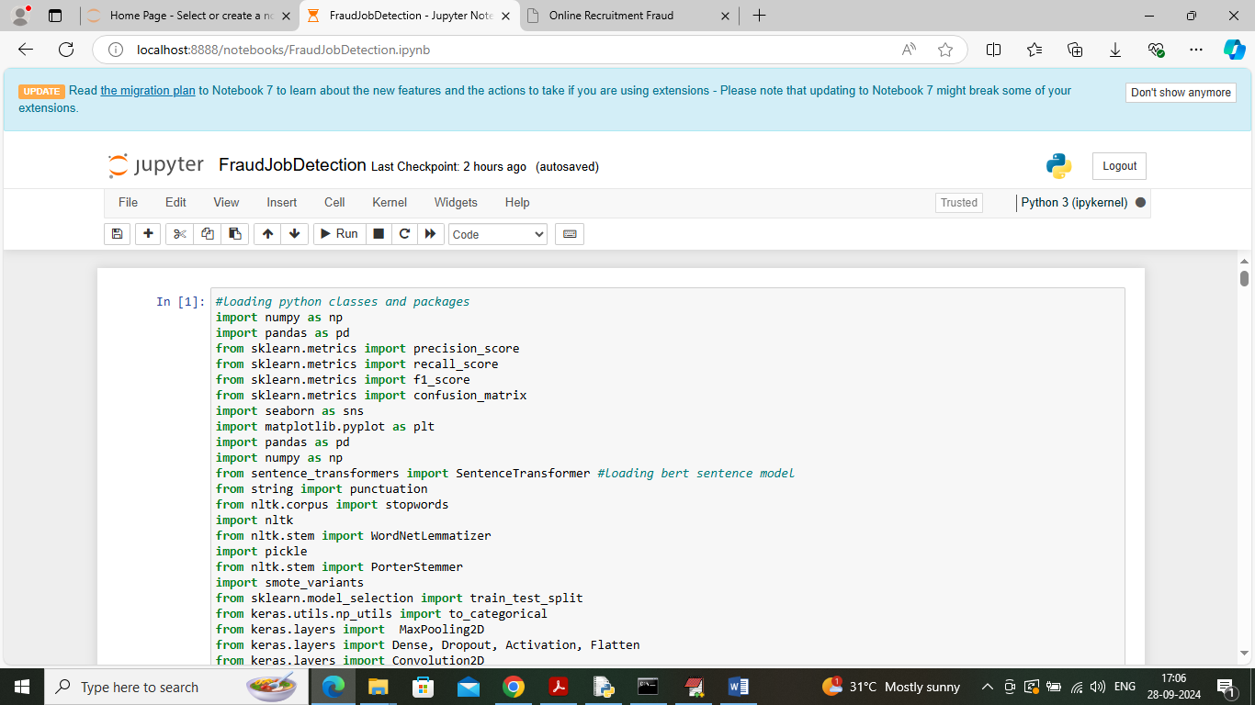

In above screen importing required packages and classes

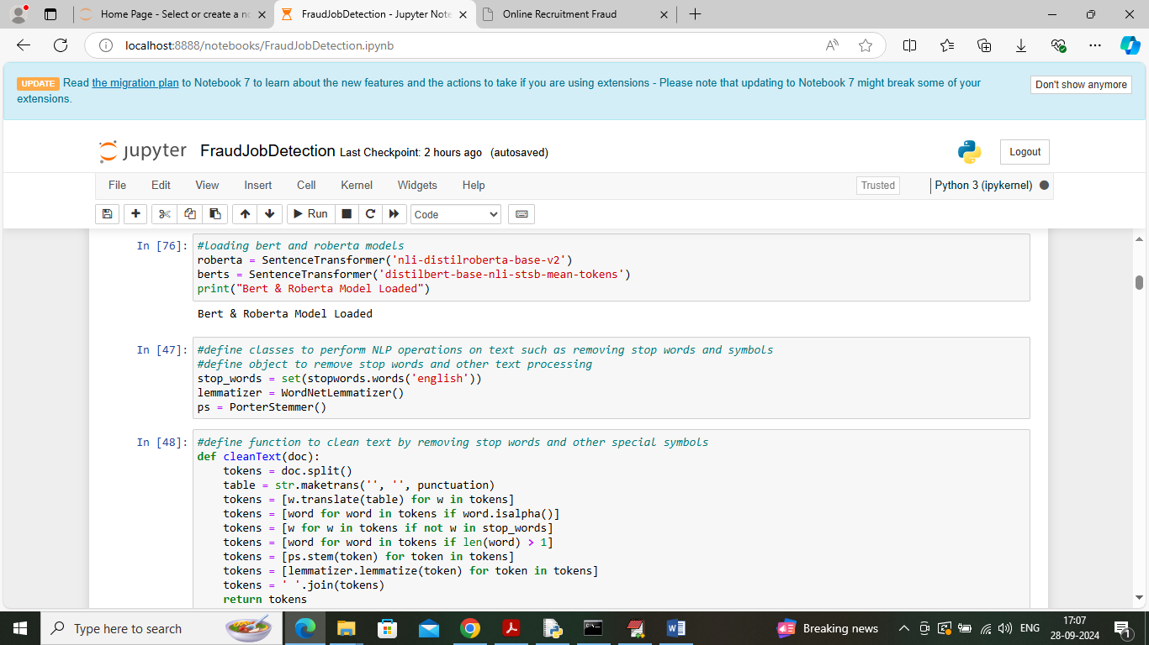

In above screen in first block creating and loading objects of BERT and Roberta models and then defining function to clean text data using NLP algorithms

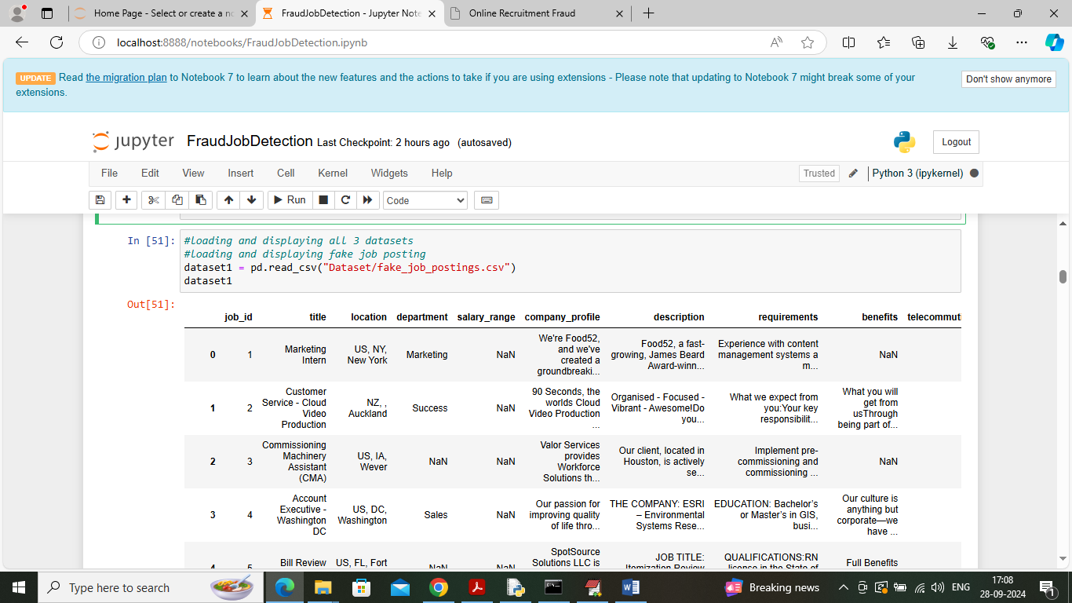

In above screen loading and displaying Fake job first dataset values

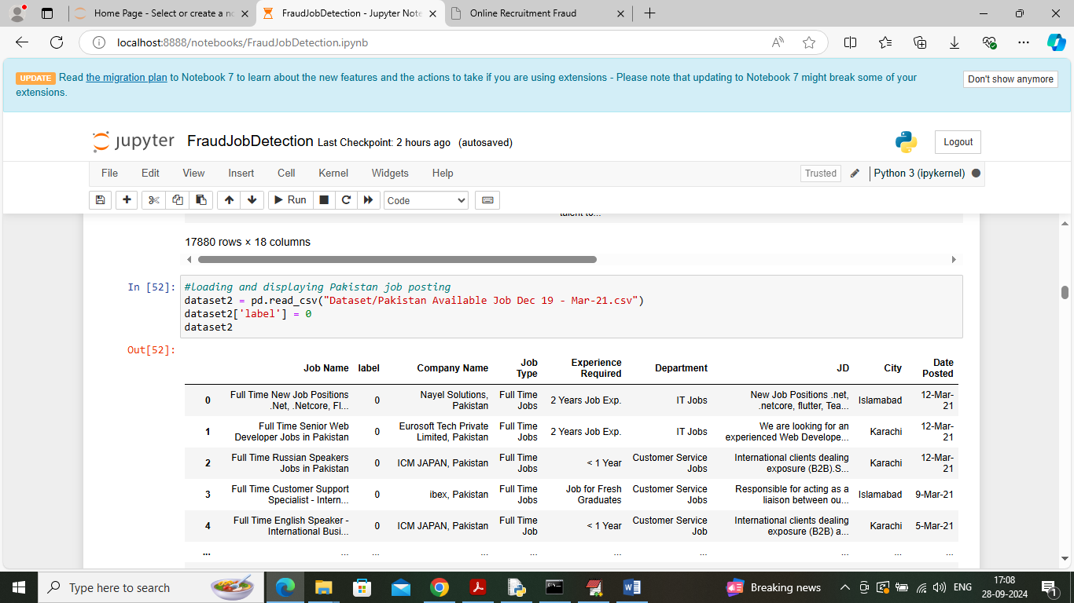

In above screen loading and displaying second dataset values

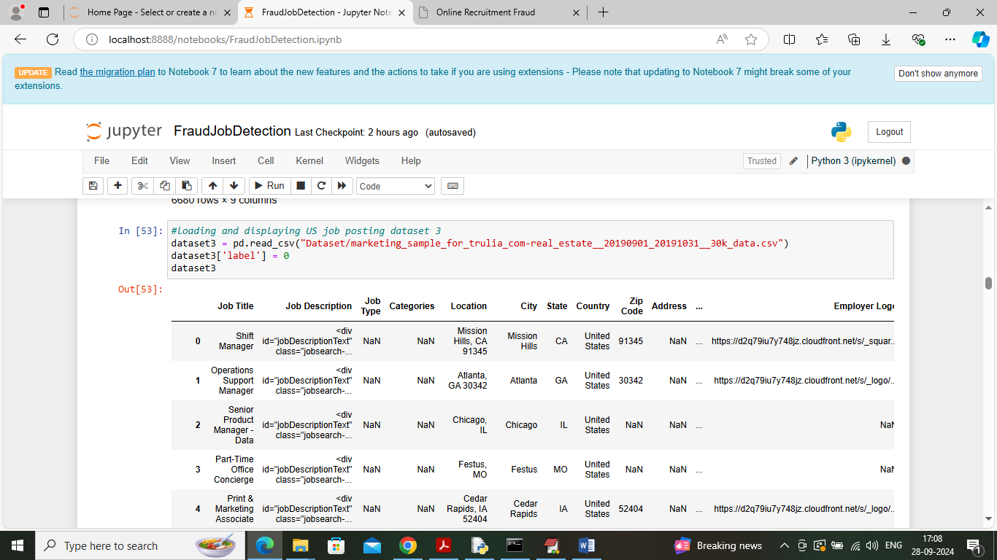

In above screen loading and displaying 3rd dataset values

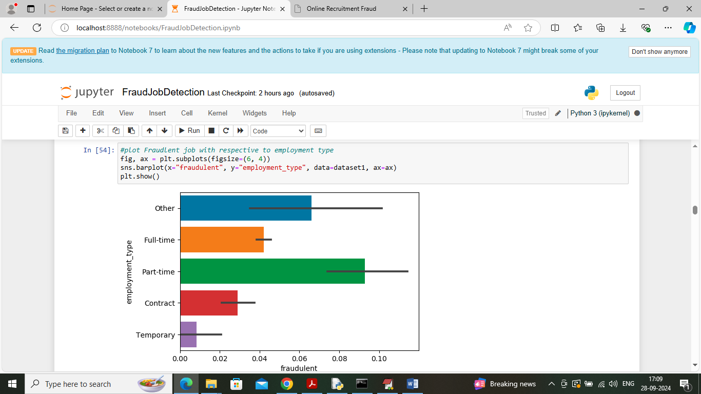

In above screen visualizing fraud job percentage in dataset with respect to employment type and in above graph can see ‘Part Time’ job type contains more fraud job. In above graph x-axis represents fraud job percentage and y-axis represents employment type

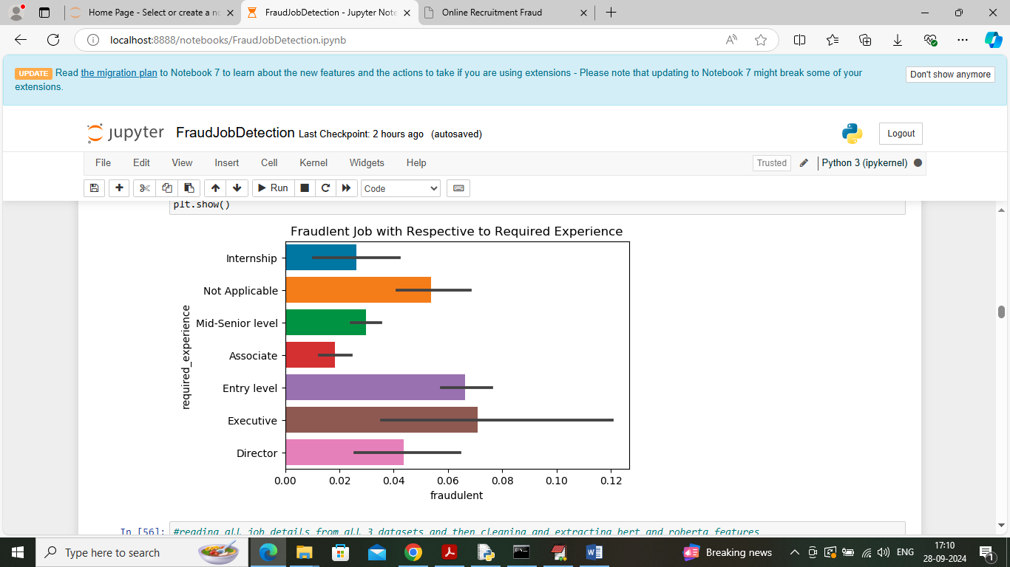

In above screen visualizing fraud job percentage with respect to ‘Required Experience’ and in above exploration we can say ‘Executive’ experience contains more fraud jobs

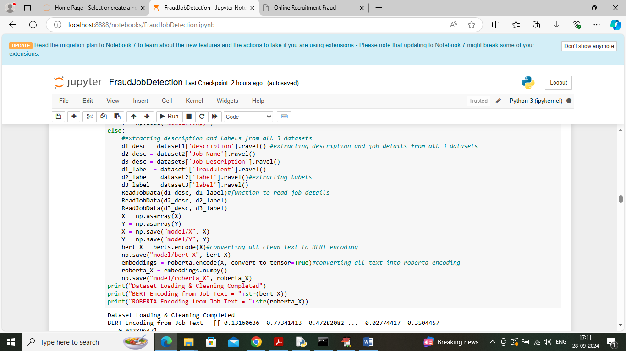

In above screen reading all job details from all 3 datasets and then input to BERT and Roberta to convert job details in to numeric vector and after executing above blocks will get below output

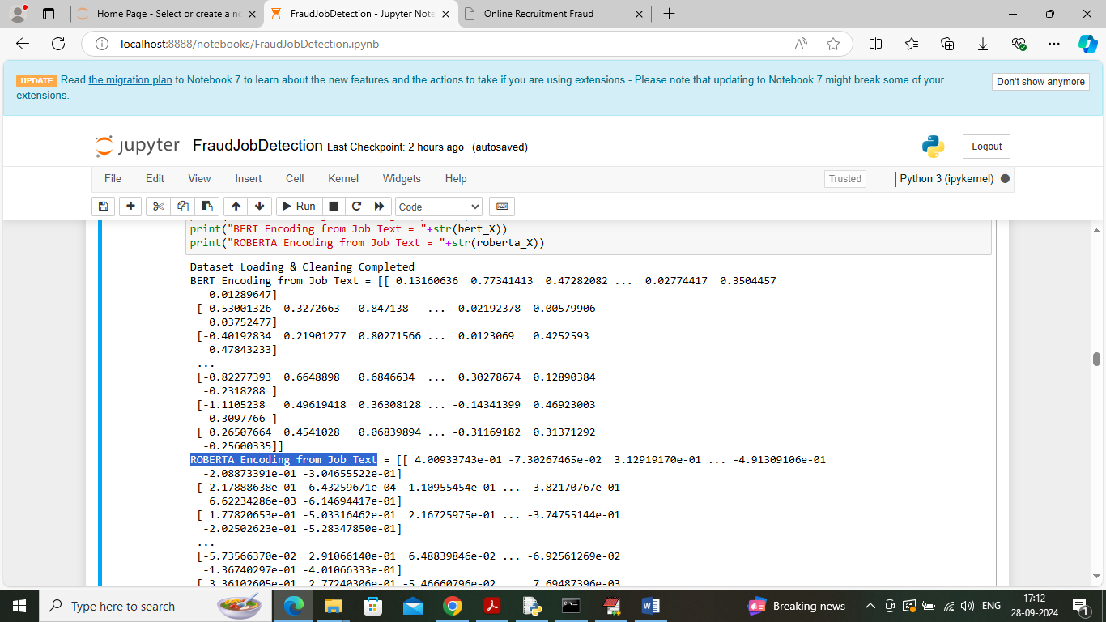

In above screen can see numeric vector generated from job text for both BERT and Roberta models

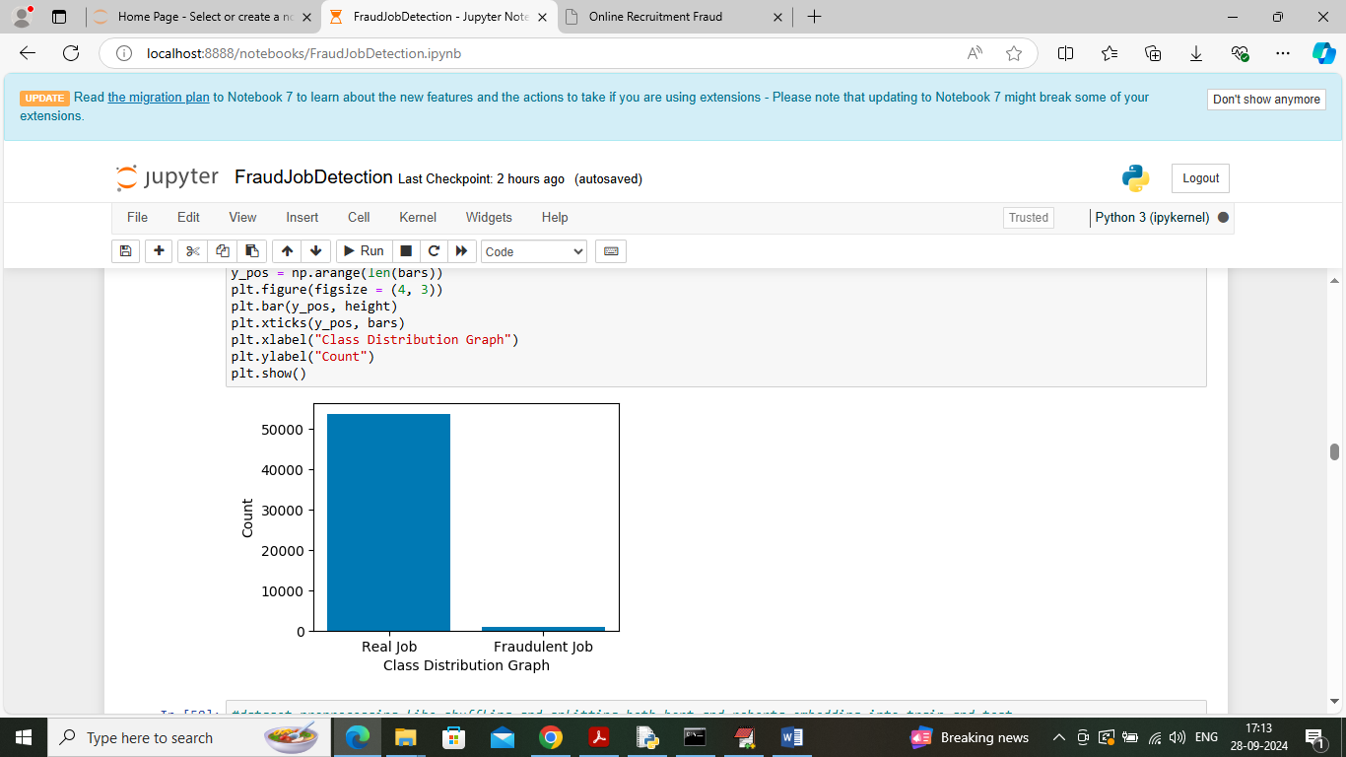

In above screen visualizing REAL and Fraud number of jobs exists in dataset and can see more jobs posting are REAL and very few records contains FAKE job posting and this having high imbalance data issue. In above graph x-axis represents Job Type and y-axis represents number of records

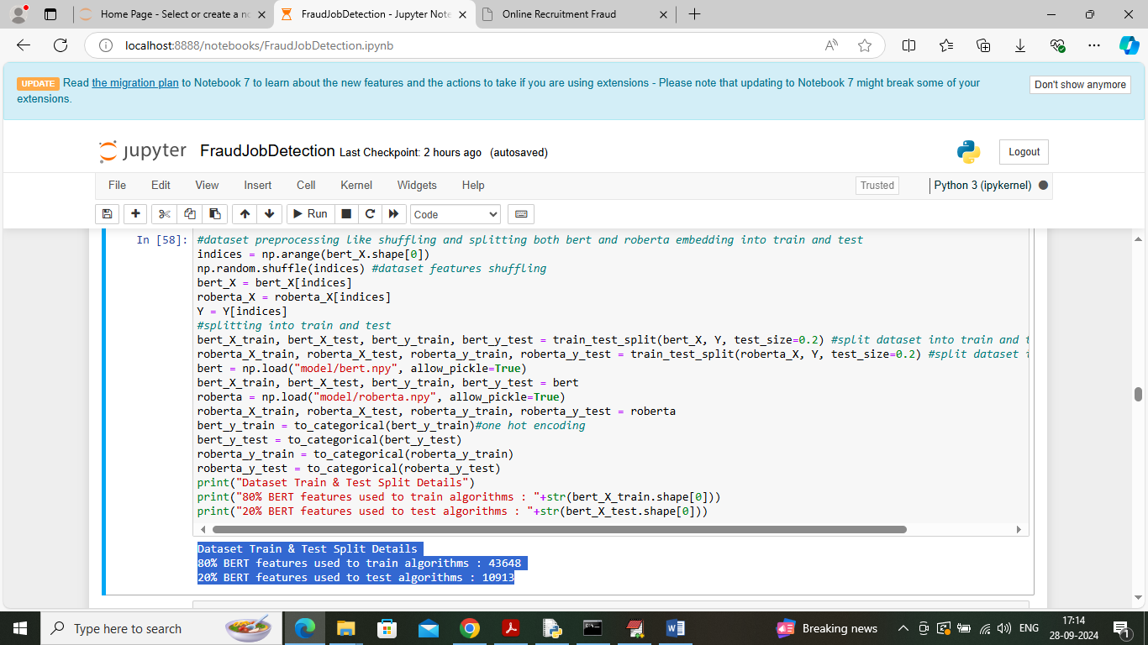

In above screen applying processing techniques such as shuffling and splitting data into train and test where 80% BERT and Roberta features will used for training and 20% for testing

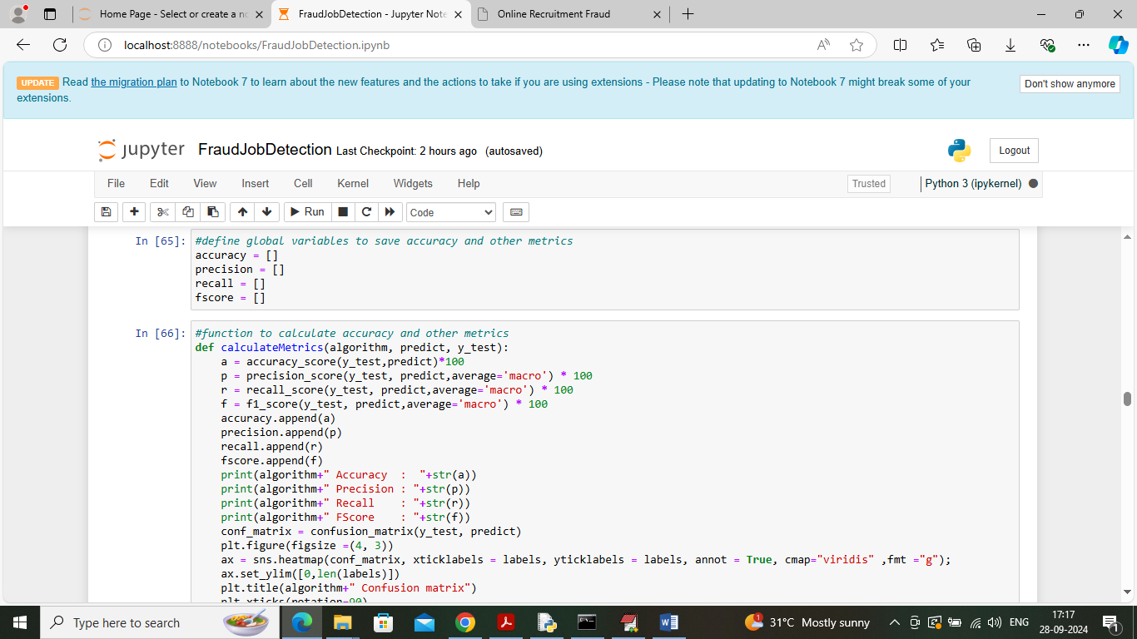

In above screen defining function to calculate accuracy and other metrics

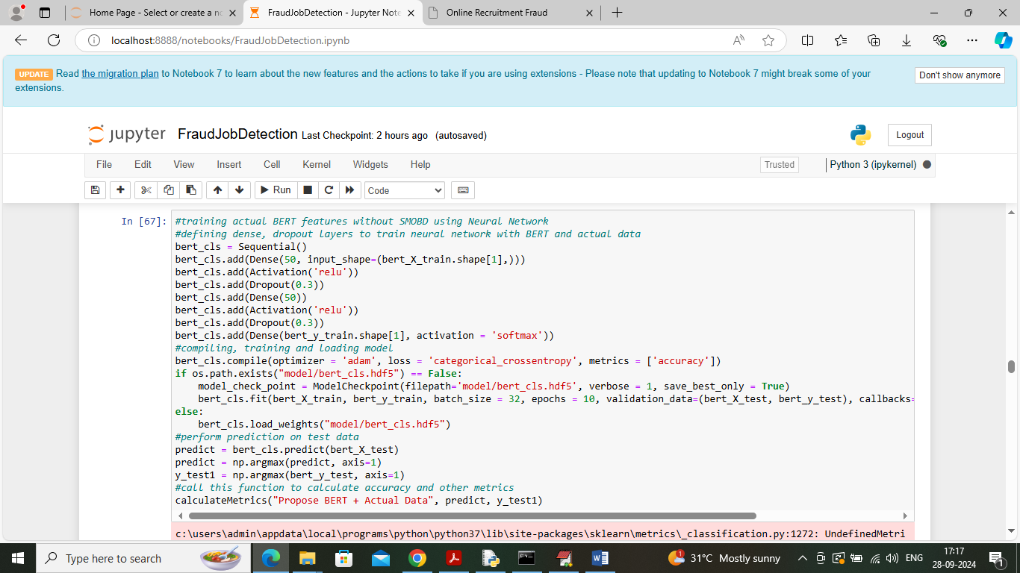

In above screen training BERT features without SMOTE which means actual data and after executing this block will get below output

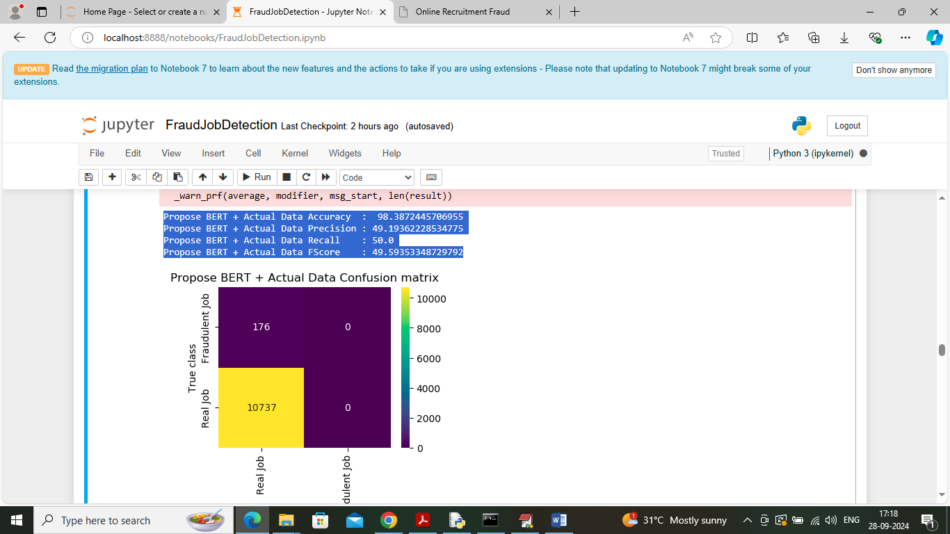

In above screen BERT neural network with actual data got 98% accuracy and can see other metrics like precision, recall and FSCORE. In confusion matrix graph x-axis represents Predicted Labels and y-axis represents true labels and then yellow and blue boxes in diagonal represents correct prediction count and remaining both blue boxes represents incorrect prediction count. In above graph can see without using SMOTE classifier predicted all jobs as REAL and fake count is 0 and this will happened because of imbalance data issue and can solve this issue using SMOTE invariants classes.

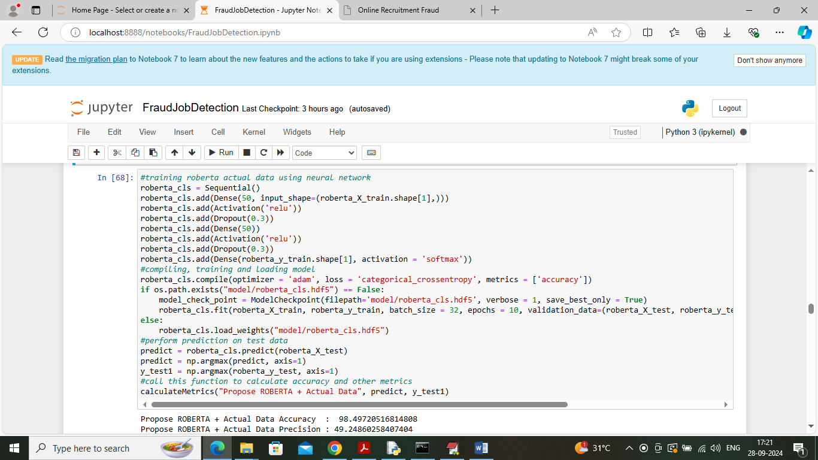

In above screen training ROBERTA features with neural network algorithm and below is the output

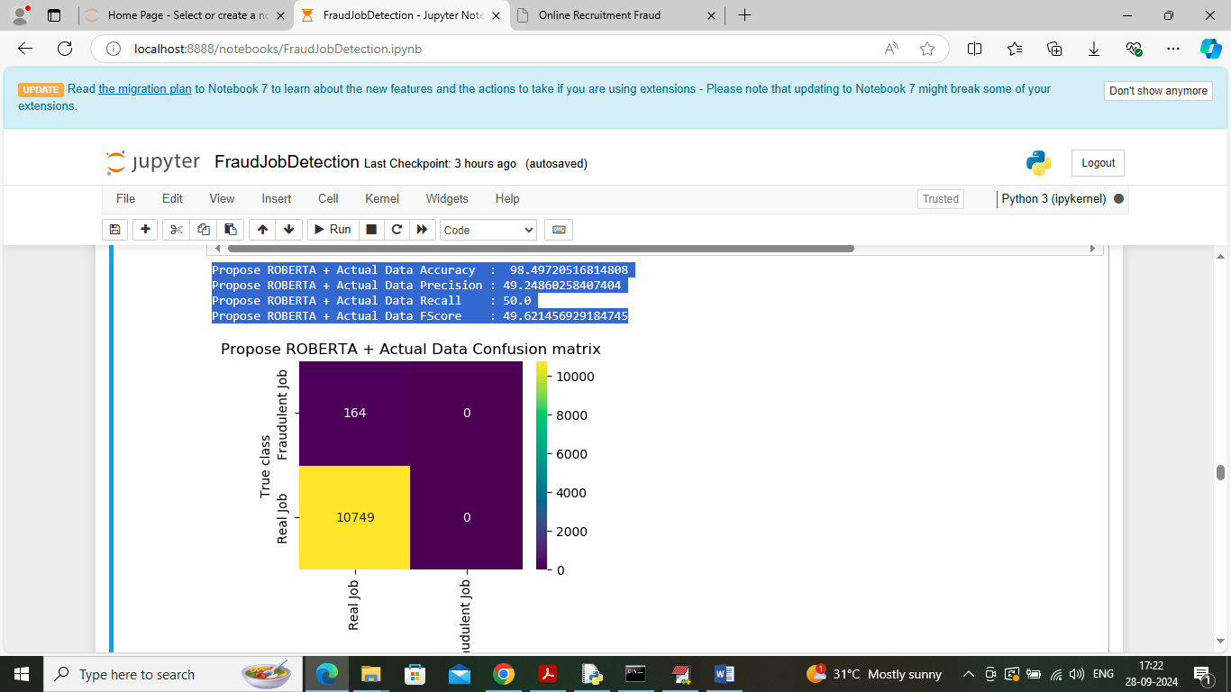

In above screen Roberta got 98.49% accuracy and this algorithm also without SMOTE predicted all jobs as REAL and O fake jobs predicted.

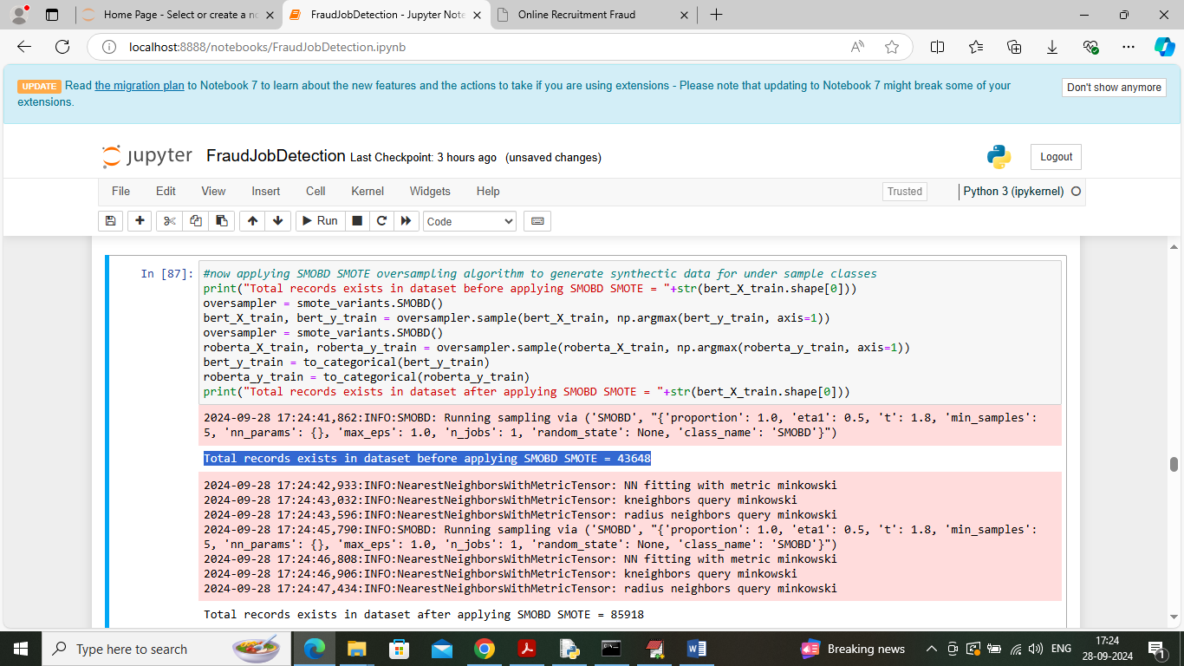

In above screen applying SMOTE SMOBD algorithm on both BERT and Roberta features and then in blue colour text can see dataset contains 41000 records and in last line after applying SMOTE we can see dataset features size increase to 85000

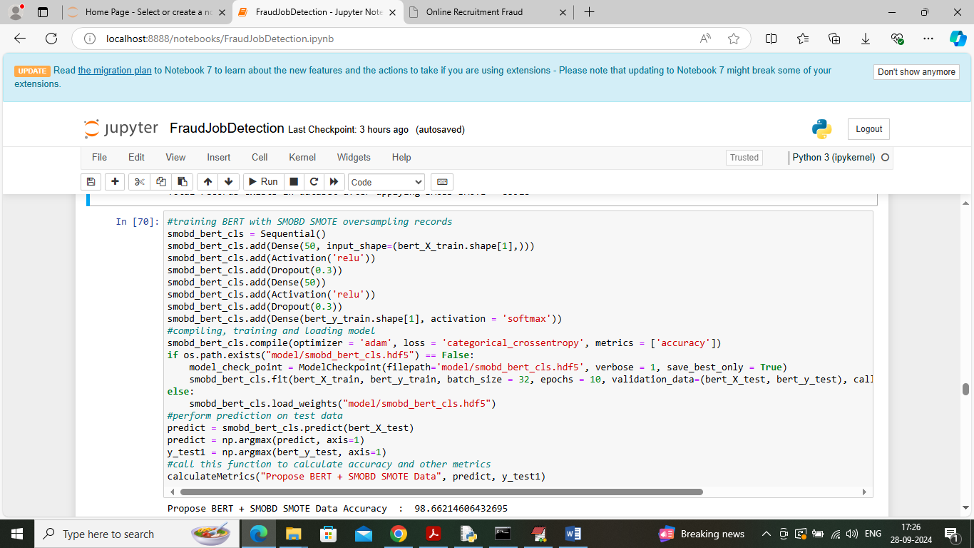

In above screen training Neural Network with BERT + SMOTE SMOBD algorithm and after executing above block will get below output

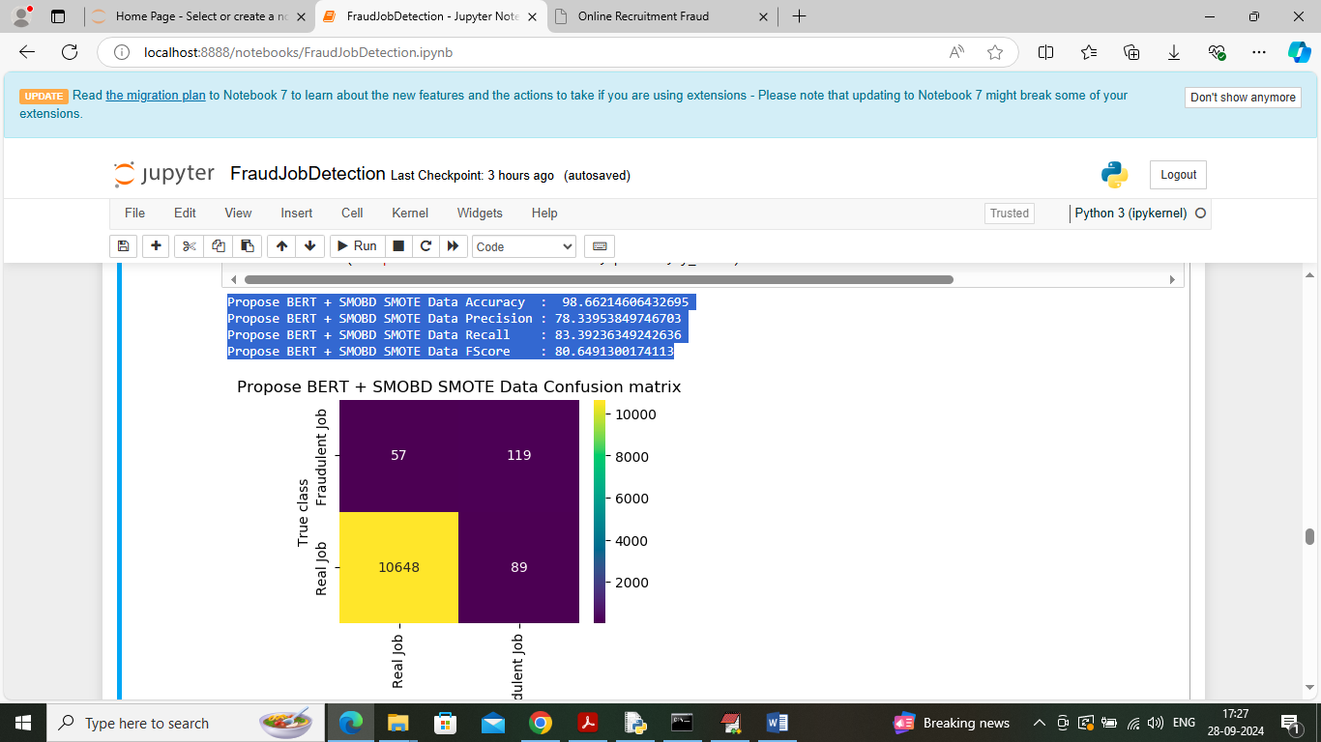

In above screen BERT + SMOTE got 988.66% accuracy and in confusion matrix graph we can see algorithm predicted both real and fraud jobs as no class has 0 predicted count which we see in previous confusion matrix without SMOTE

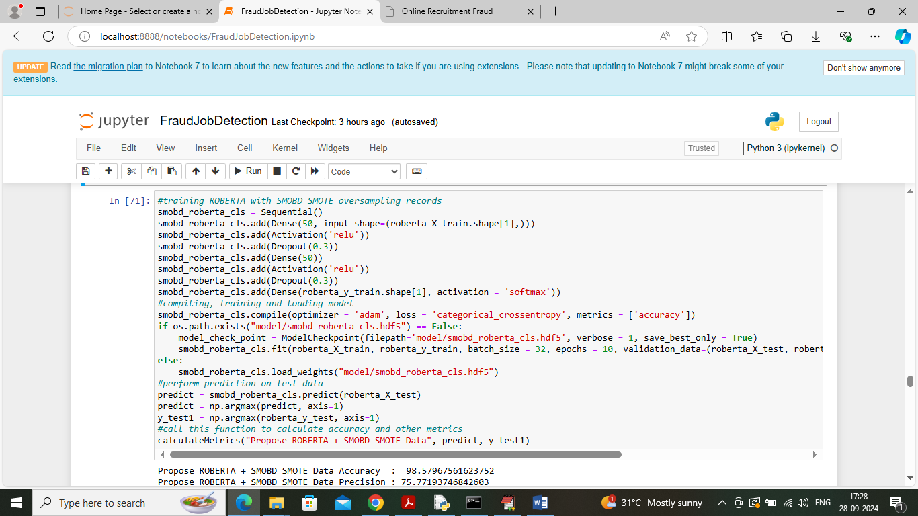

In above screen training neural network with Roberta + SMOTE features and after executing above block will get below output

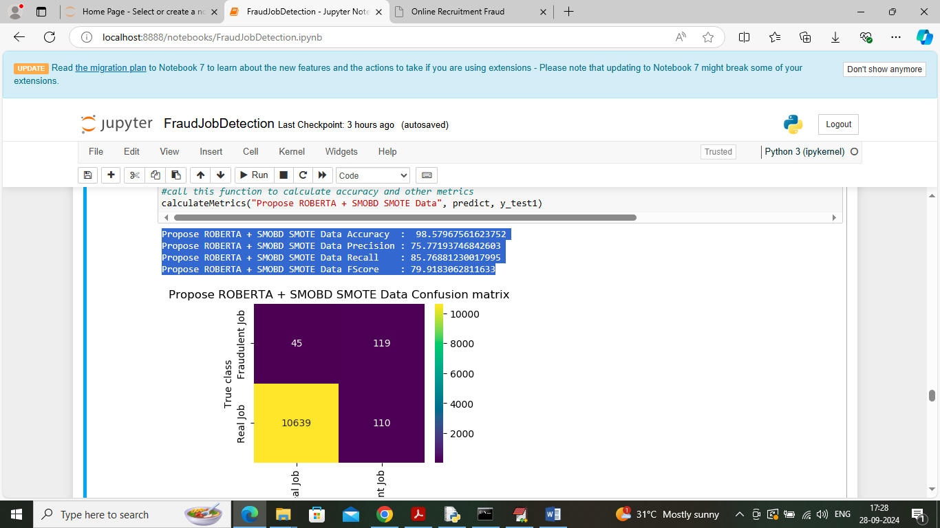

In above screen Roberta + SMOTE got 98.57% accuracy and can see this algorithm also predicted both Real and Fake jobs

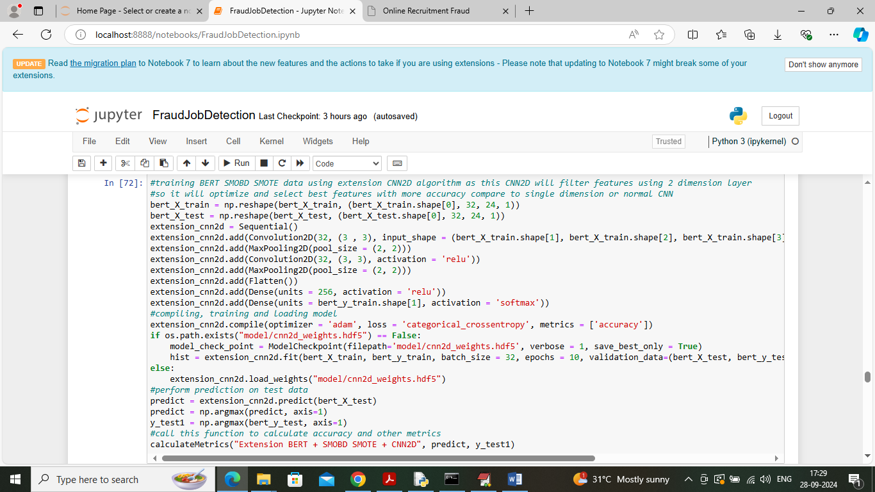

In above screen training extension CNN2D algorithm using BERT + SMOTE features and after executing above block will get below output

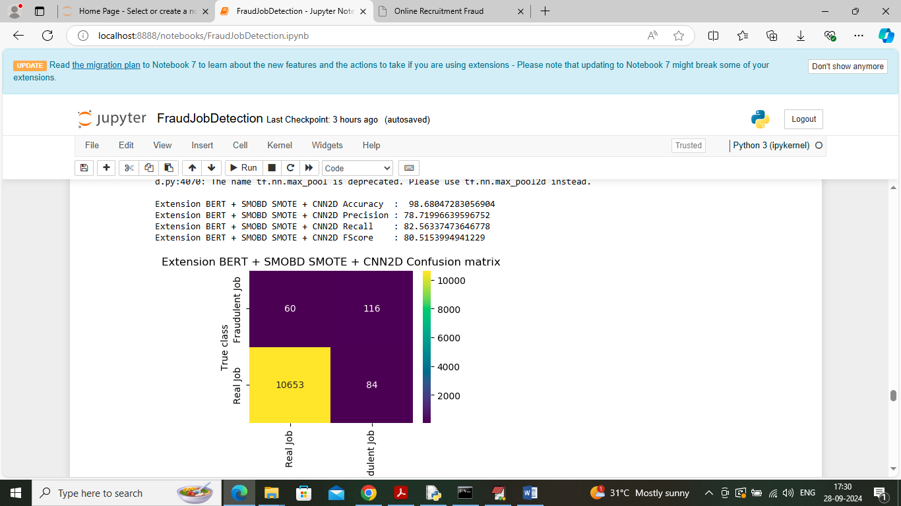

In above screen extension got 98.68% accuracy which is higher than all propose algorithms and in confusion matrix can see both real and fake jobs predicted

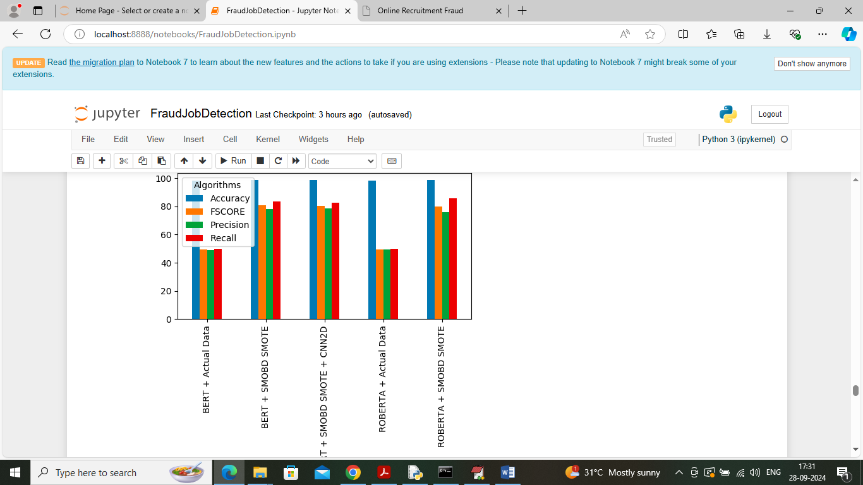

In above screen displaying all algorithm performance comparison graph where x-axis represents algorithm names and y-axis represents accuracy and other metrics in different colour bars and in all algorithms Extension got high accuracy

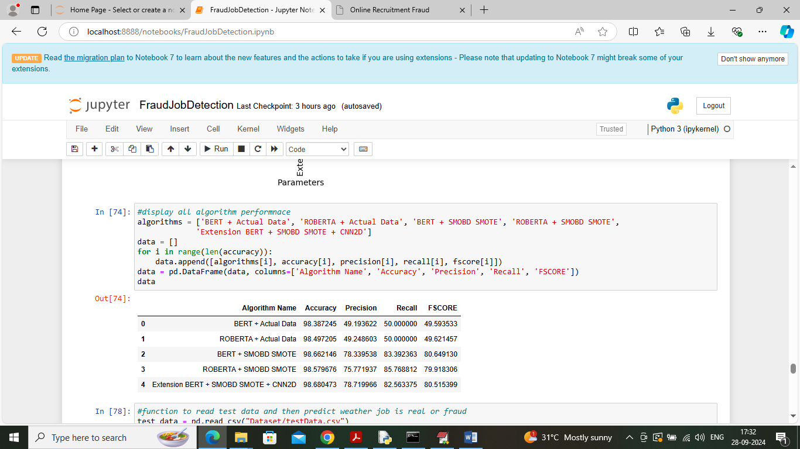

In above screen displaying all algorithm performance in tabular format

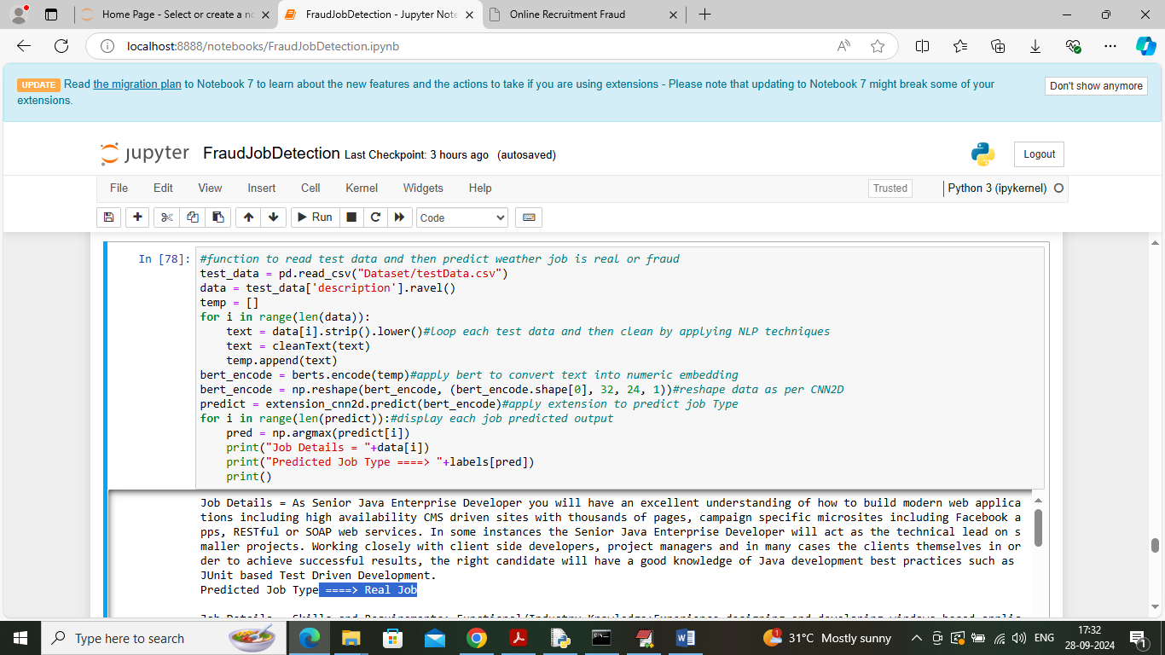

In above screen reading test data job details and then applying BERT encoding along with extension CNN2D to predict test data job type and in output can see Job Description and then in blue colour text can see predicted job type

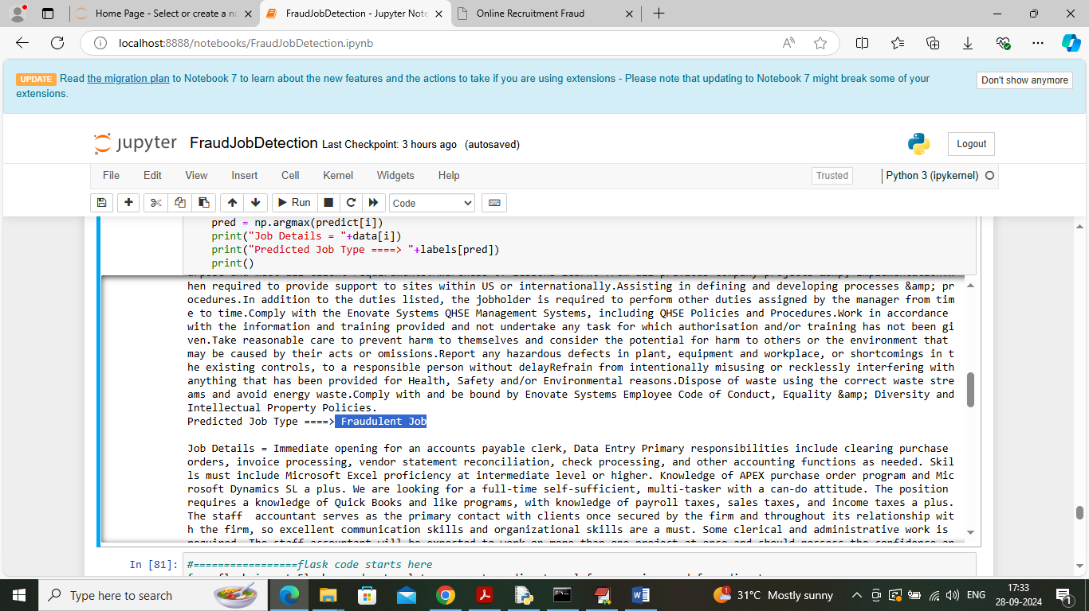

In above screen Fraud job also predicted

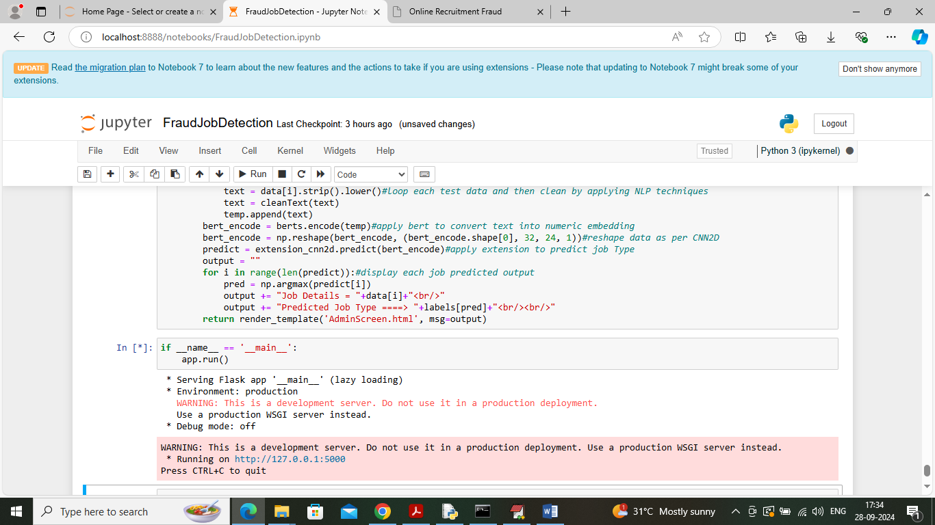

In above screen run all flask blocks to start flask server and then open browser and enter URL as <http://127.0.0.1:5000/index> and then press button to get below page

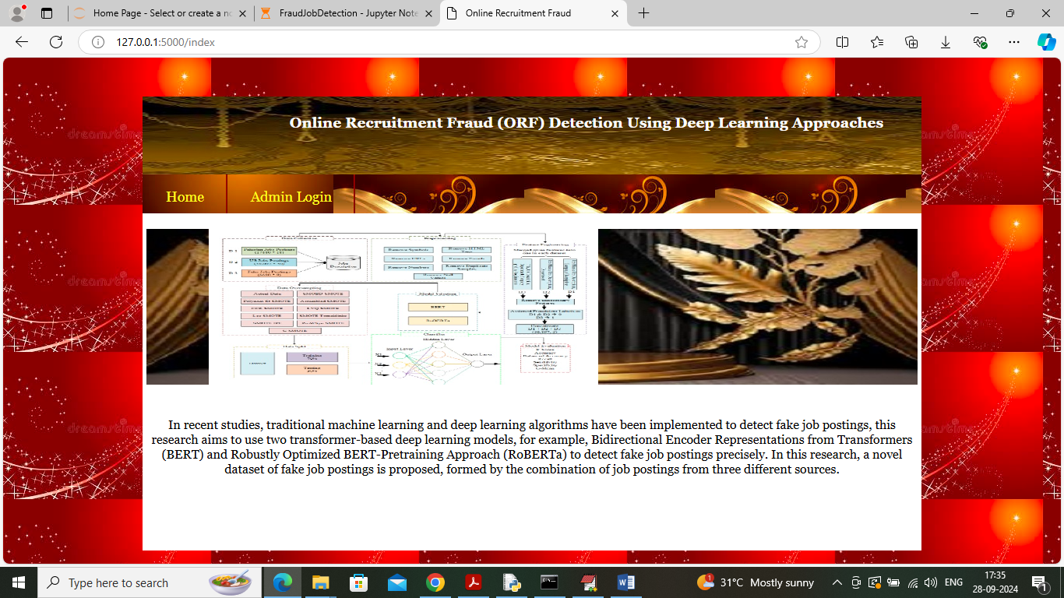

In above screen click on ‘Admin Login’ link to get below page

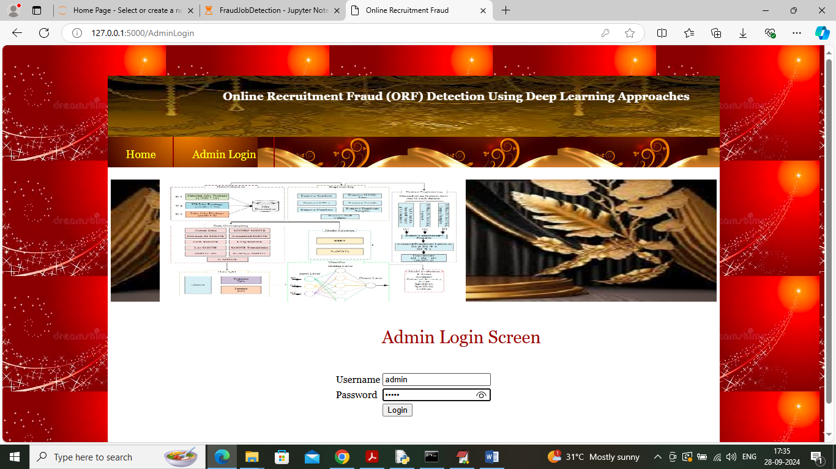

In above screen admin is login and after login will get below page

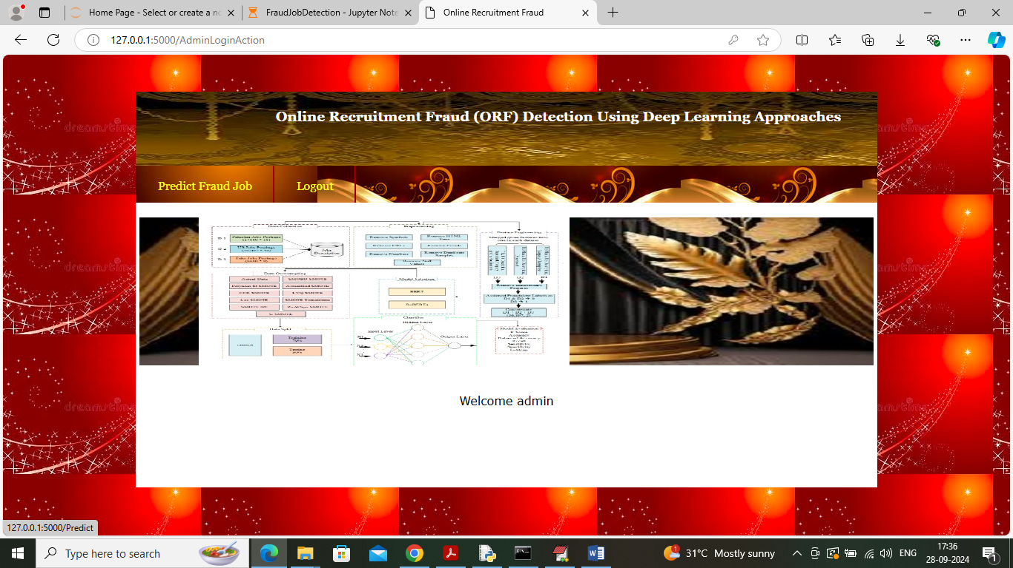

In above screen click on ‘Predict Fraud Job’ link to get below page

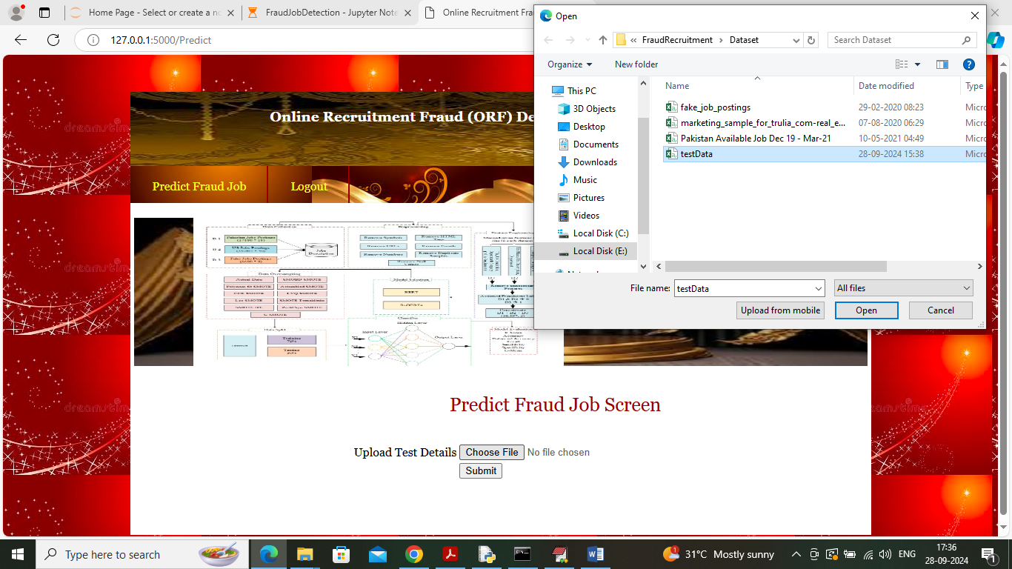

In above screen select and upload test file and then click on ‘Open’ and ‘Submit’ button to get below output



In above screen first can see Job text details and then can see predicted Job Type